Kindergarten Notification Information
December 2012

A recently enacted Michigan law amended the Revised School Code (MCL 380.1147), which changed the minimum age requirement for a child enrolling in kindergarten. Currently, a student must be five years old by December 1st to be eligible for enrollment to kindergarten. New legislation will change the “cut-off” date and will be gradually phased-in over three years; changing the requirement by one month each year. The changes will be implemented in the following manner:

- For the 2013-14 school year, children must be five years old by November 1st

- For the 2014-15 school year, children must be five years old by October 1st

- For the 2015-16 school year, children must be five years old by September 1st

Parent Notification Option
If the child is not eligible for enrollment per the guidelines specified above and will be five years old by December 1st, the child’s parent or legal guardian can apply for a waiver to enroll their student in school. Notification deadlines and other information are as follows:

- If the child resides in the school district, the notification must be submitted to the school district no later than June 1st before the beginning of the school year.

- If the child becomes a resident of the school district after June 1st, the notification must be submitted to the school district no later than August 1st before the beginning of the school year.

- When in receipt of notification, districts can make recommendations to the child’s parent or legal guardian, as to the child’s readiness for school, and whether or not the child should be enrolled early.

- Regardless of a district’s recommendation, the parent or legal guardian retains the sole discretion to enroll their child.

MPAAA has created three notification forms for districts to use, which are included in this document. In addition, we have included a poster created by the West Shore ESD and shared with the Michigan School Public Relations Association (MSPRA). Feel free to customize these forms as needed however, please retain the source credit.

We hope you find these tools helpful!

1001 Centennial Way • Suite 400 • Lansing, MI 48917 • (517) 512-0171
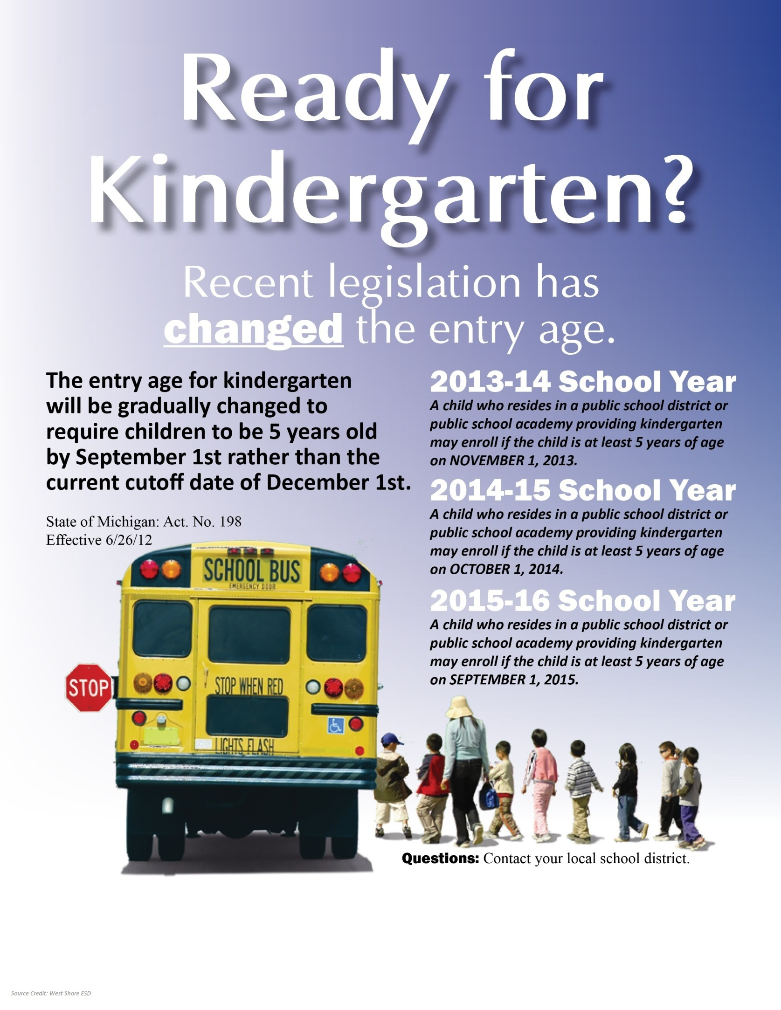
{District/School Name}
{DistrictSchool Address}
Kindergarten Notification Request for 2013-2014 School Year

According to Michigan Law, if a child residing in {District Name} is not five years of age on November 1, 2013 but will be five years of age not later than December 1, 2013, the parent or legal guardian of that child may enroll the child in kindergarten for the 2013-2014 school year if the parent or legal guardian notifies the school district in writing not later than June 1, 2013, that he or she intends to enroll the child in kindergarten. If a child becomes a resident of the {District Name} after June 1, the child's parent or legal guardian may enroll the child in kindergarten for that school year if the parent or legal guardian submits this written notification not later than August 1, 2013 under this subsection.

A school district that receives this written notification may make a recommendation to the parent or legal guardian as to whether the child is not ready to enroll in kindergarten due to the child's age or other factors. Regardless of the district recommendation, the parent or legal guardian retains the sole discretion to determine whether or not to enroll the child in kindergarten if the student is five years of age not later than December 1, 2013.

Student Name: ______________________________________________ Date of Birth: _________________

Verification of Age: Birth Certificate Government Record Hospital Record
(Check one) Court Record Citizenship Paper Other: _________________
(Specify)

Evidence of School Readiness (provided by parent):

- ___________________________________________________________________________________________

- ___________________________________________________________________________________________

- ___________________________________________________________________________________________

- ___________________________________________________________________________________________

_____________________________________ ________________________________ ___________________
Parent/Guardian’s Printed Name Parent/Guardian’s Signature Date

{District/School Name} Recommendation

{Administrator’s Name} agrees with the recommendation of the parents to enroll in Kindergarten.
{Administrator’s Name} recommends kindergarten begin in September 2014 for the following reasons:

- ____________________________________________________________________________

- ____________________________________________________________________________

- ____________________________________________________________________________

- ____________________________________________________________________________

____________________________________________________________________________ ___________________
School Administrator’s Signature Date

MPAAA © 2012 (MPAAA.org)
{District/School Name}
{DistrictSchool Address}
Kindergarten Notification Request for 2014-2015 School Year

According to Michigan Law, if a child residing in {District Name} is not five years of age on October 1, 2014 but will be five years of age not later than December 1, 2014, the parent or legal guardian of that child may enroll the child in kindergarten for the 2014-2015 school year if the parent or legal guardian notifies the school district in writing not later than June 1, 2014, that he or she intends to enroll the child in kindergarten. If a child becomes a resident of the {District Name} after June 1, the child's parent or legal guardian may enroll the child in kindergarten for that school year if the parent or legal guardian submits this written notification not later than August 1, 2014 under this subsection.

A school district that receives this written notification may make a recommendation to the parent or legal guardian as to whether the child is not ready to enroll in kindergarten due to the child's age or other factors. Regardless of the district recommendation, the parent or legal guardian retains the sole discretion to determine whether or not to enroll the child in kindergarten if the student is five years of age not later than December 1, 2014.

Student Name: ______________________________________________ Date of Birth: _________________

Verification of Age: Birth Certificate Government Record Hospital Record
(Check one) Court Record Citizenship Paper Other: _________________
(Specify)

Evidence of School Readiness (provided by parent):

- ___________________________________________________________________________________________

- ___________________________________________________________________________________________

- ___________________________________________________________________________________________

- ___________________________________________________________________________________________

_____________________________________ ________________________________ ___________________
Parent/Guardian’s Printed Name Parent/Guardian’s Signature Date

{District/School Name} Recommendation

{Administrator’s Name} agrees with the recommendation of the parents to enroll in Kindergarten.
{Administrator’s Name} recommends kindergarten begin in September 2015 for the following reasons:

- ____________________________________________________________________________

- ____________________________________________________________________________

- ____________________________________________________________________________

- ____________________________________________________________________________

____________________________________________________________________________ ___________________
School Administrator’s Signature Date

MPAAA © 2012 (MPAAA.org)
{District/School Name}
{DistrictSchool Address}
Kindergarten Notification Request for 2015-2016 School Year

According to Michigan Law, if a child residing in {District Name} is not five years of age on September 1 but will be five years of age not later than December 1, the parent or legal guardian of that child may enroll the child in kindergarten for the current school year if the parent or legal guardian notifies the school district in writing not later than June 1 that he or she intends to enroll the child in kindergarten. If a child becomes a resident of the {District Name} after June 1, the child's parent or legal guardian may enroll the child in kindergarten for that school year if the parent or legal guardian submits this written notification not later than August 1 under this subsection.

A school district that receives this written notification may make a recommendation to the parent or legal guardian as to whether the child is not ready to enroll in kindergarten due to the child's age or other factors. Regardless of the district recommendation, the parent or legal guardian retains the sole discretion to determine whether or not to enroll the child in kindergarten if the student is five years of age not later than December 1.

Student Name: ______________________________________________ Date of Birth: _________________

Verification of Age: Birth Certificate Government Record Hospital Record
(Check one) Court Record Citizenship Paper Other: _________________
(Specify)

Evidence of School Readiness (provided by parent):

- ___________________________________________________________________________________________

- ___________________________________________________________________________________________

- ___________________________________________________________________________________________

- ___________________________________________________________________________________________

_____________________________________ ________________________________ ___________________
Parent/Guardian’s Printed Name Parent/Guardian’s Signature Date

{District/School Name} Recommendation

{Administrator’s Name} agrees with the recommendation of the parents to enroll in Kindergarten.
{Administrator’s Name} recommends kindergarten begin in September of next year for the following reasons:
- ____________________________________________________________________________

- ____________________________________________________________________________

- ____________________________________________________________________________

- ____________________________________________________________________________

____________________________________________________________________________ ___________________
School Administrator’s Signature Date

MPAAA © 2012 (MPAAA.org)

